Assembly 2 – worksheet
List the hexadecimal code for the following program (hand-assemble it) and the symbol table:
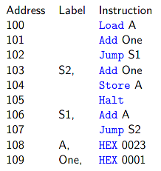
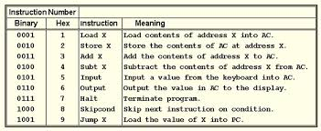
1108
3109
9106
3109
2108
0111
3108
9103

Given the instruction set for MARIE in this chapter:
- Decipher the following MARIE machine language instructions (write the assembly language equivalent):
  - 001000000001011
0010 0000 0000 1011
2 0 0 B Jump 00B
  - 011000000001001
0110 0000 0000 1001
6 0 0 9 Output 009

Write the following code segment in MARIE’s assembly language:
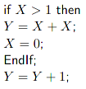

IF, LOAD X
SUBT ONE
SKIPCOND
JUMP ENDIF
THEN, LOAD X
ADD X
STORE Y
CLEAR
STORE X
ENDIF, LOAD Y
ADD ONE
STORE Y
HALT
ONE, DEC 1
X, DEC ?
Y, DEC ?

Trace the fetch-decode-execute cycle for the following program:
